Forced charging operation steps

Step 1 Open the maintenance cover of battery , find the positive pole + and negative pole - of the battery. Check voltage by multimeter ,For example 60V.
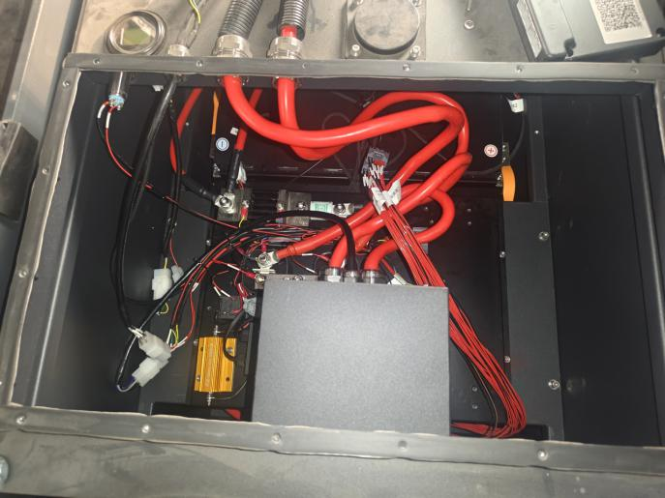
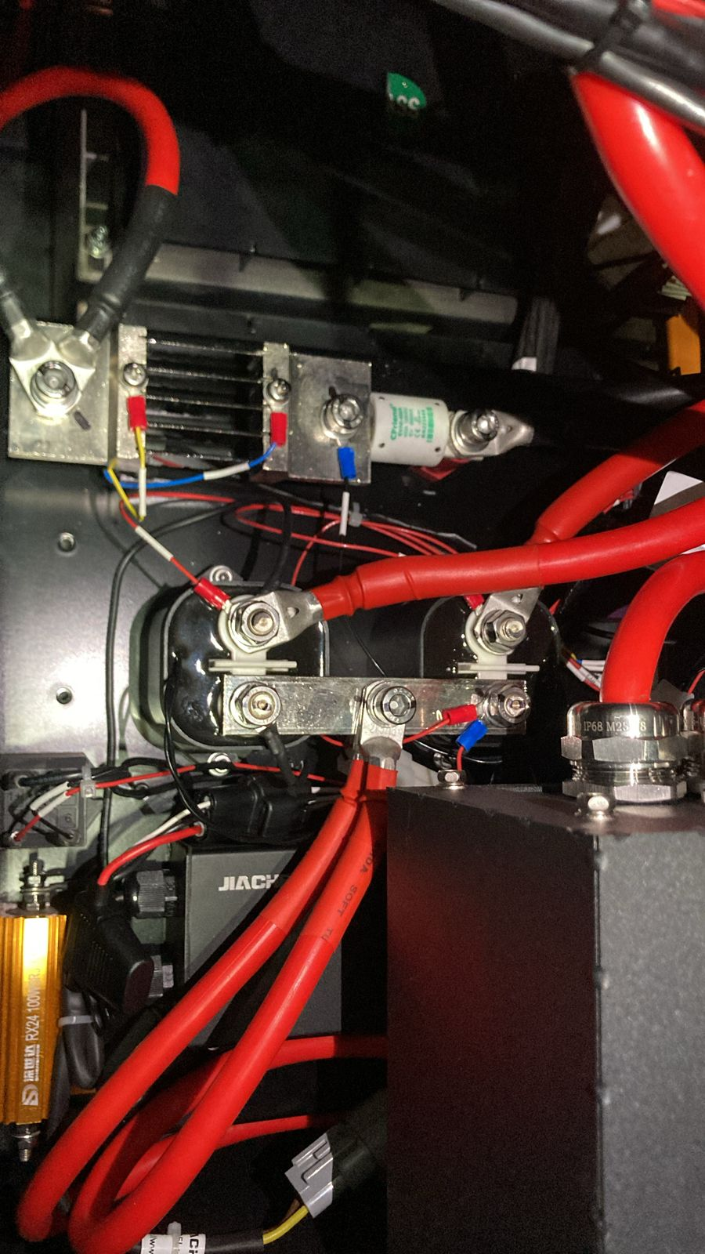
Negative pole -
Positive pole +

Step 2
Adjust the wire position. Loosen 2 nuts and remove the wire from position 1 to position 2,then fix the nuts
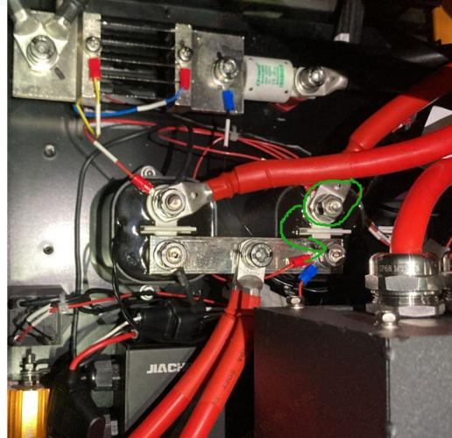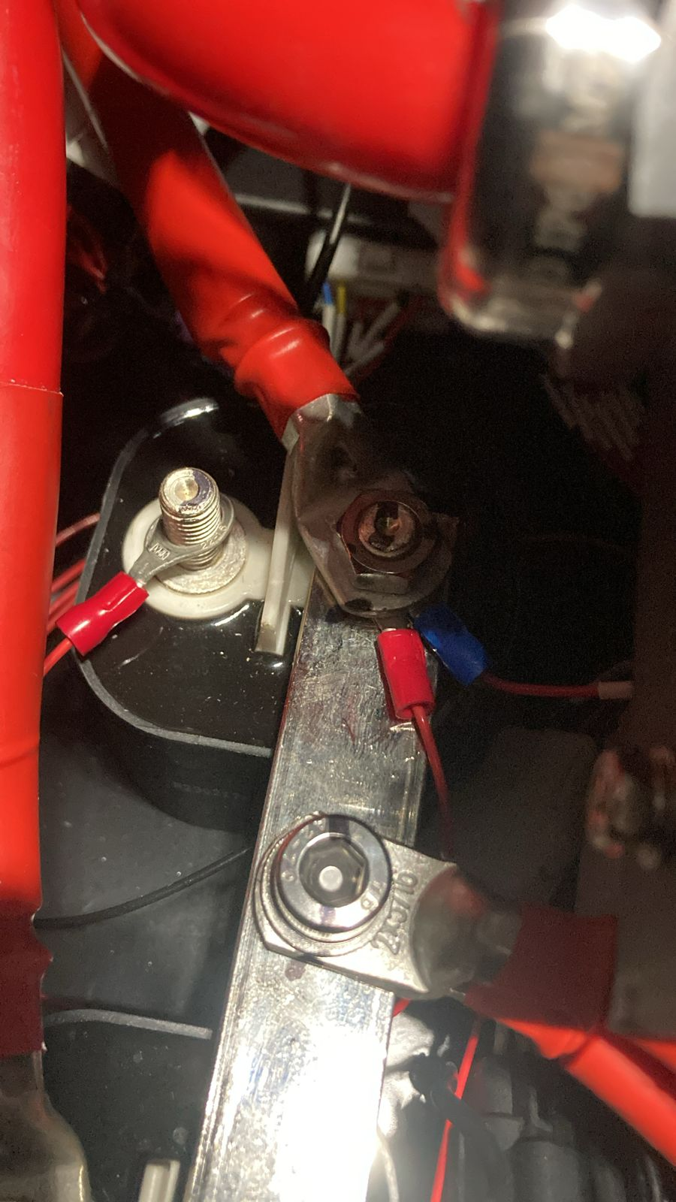
position 2
position 1

Step 3
Click up-left side of the charger screen , then find Dubug mode setting,Input Password 228958.
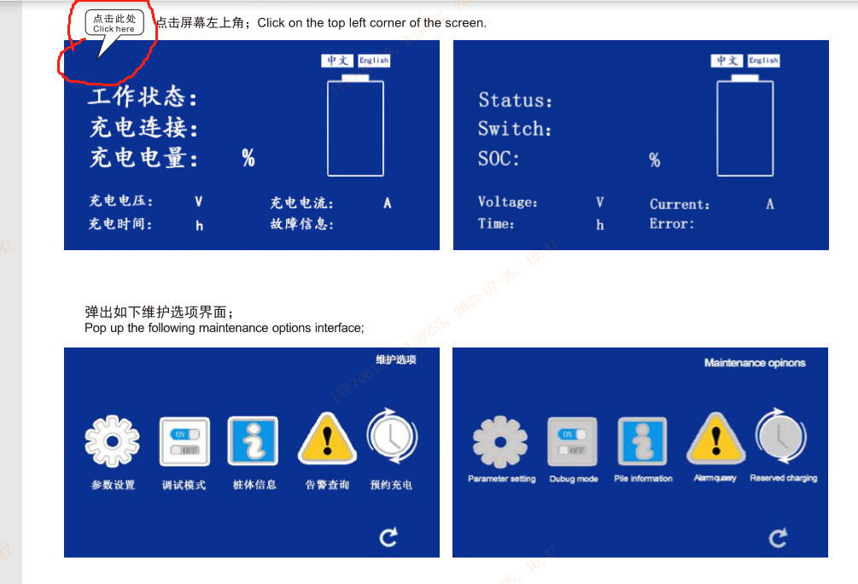
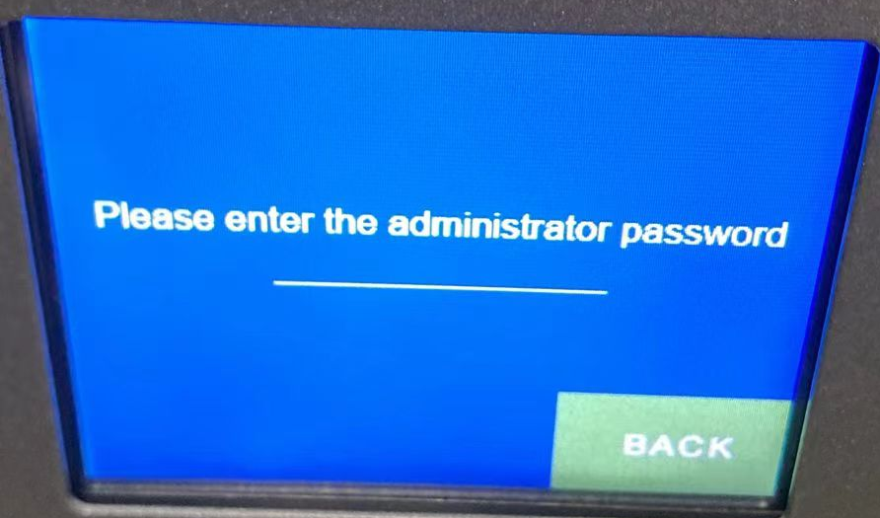
Then input voltage 80V, Current 5A, click the confirm button. the charger starts working.
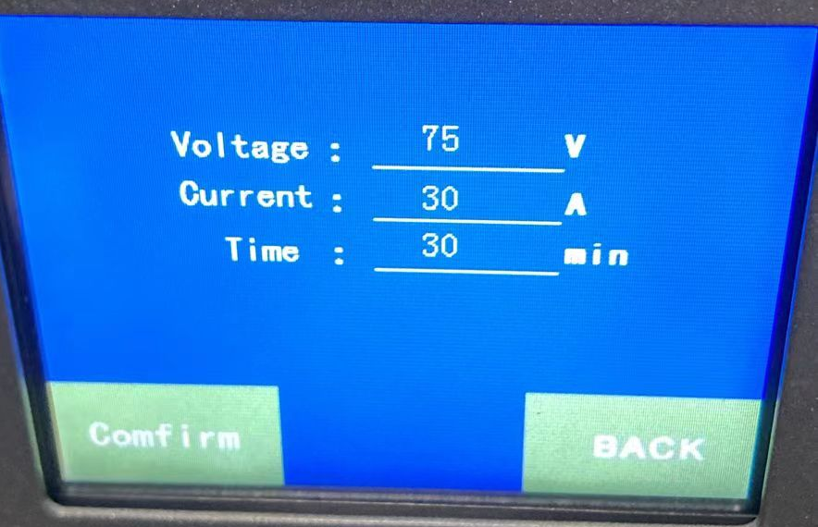

Step 4
Stop charging when the voltage is more than 80 V. Adjust the wire to its initial position.(from position 2 to position 1),Then start charging to 100% SOC.
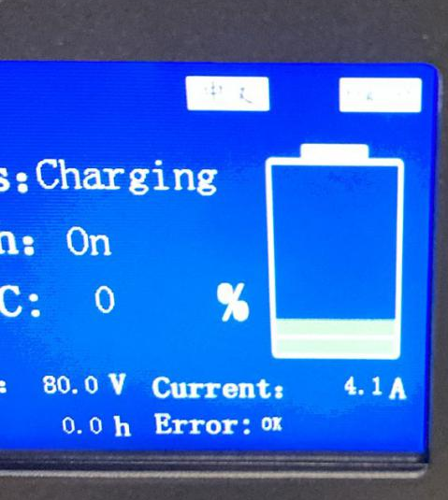
position 1

position 2

